Developing a Telebuprenorphine Program
Olivia Hood, Chris Buresh, Lauren Whiteside, Callan Fockele, Jessica Knuttel, Meg Flohr, and Herbie Duber

Background:
Like the rest of the country King County, Washington is experiencing a rapid rise in overdose deaths resulting from fentanyl use. While buprenorphine is known to decrease the risk of death from overdose and has been deregulated by the Drug Enforcement Administration, people with opioid use disorder (OUD) still face many barriers in accessing medications for opioid use disorder (MOUD). In response, King County partnered with an academic emergency department (ED)to start a telebuprenorphine hotline that is staffed by physicians 24/7.
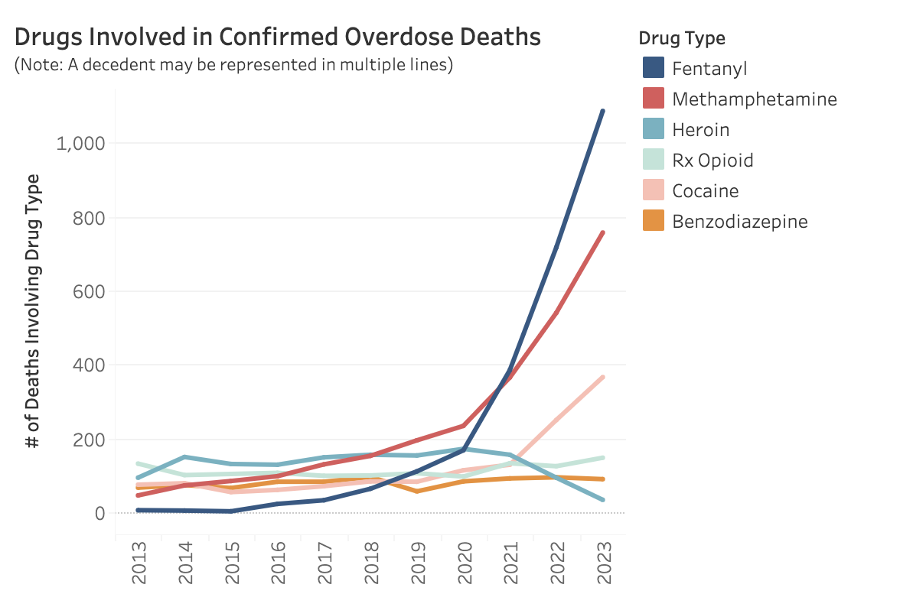

Methods:
A hotline was created using Google Voice as a platform for telephonic visits and Doxy.me as the platform for patients who prefer video visits. During daytime hours the phone would be answered by a linkage to care coordinator (LTCC) who would ensure that the patient was calling seeking MOUD, register the patient in the ED’s medical record, and collect reliable contact information. The patient would then be placed in Doxy.me’s virtual waiting room to wait for a provider or the provider would call the patient back on the phone. Providers would take a basic history, ask questions to establish a diagnosis of OUD according to the DSM V, and screen for social needs with a set of validated questions. If patients had a diagnosis of OUD, providers would send an electronic prescription to a pharmacy of their choice, along with a prescription for naloxone and other medications to treat the most bothersome symptoms of withdrawal. If patients were paying in cash, providers would also help find the lowest cost pharmacy and text them a coupon from GoodRx. Discharge instructions were also sent to the patient via text or email and patients were invited to call back for any ongoing needs.
The LTCCs would then follow up with the patients by phone and text within 72 hours to ensure that they had picked up the medications, that they were feeling better, and to answer any questions. The LTCCs would connect them with a local treatment provider of their choice for ongoing care and would help with a warm hand off if the patient wanted. The LTCCs also helped to navigate insurance problems and addressed any of the social needs identified to the best of their ability. They remained available for questions on an ongoing basis.

Results:
In the first 12 weeks of the program 104 patients were encountered through the telehealth program. Data are presented on the first 89 patients on which QI processes are complete. Of the first 89 patients, 50% were White and 66% were male. At least 15 patients (16.8%) had just been released from incarceration. Only 3 of them had gotten a prescription for buprenorphine upon release. Almost all patients (97.5%) had a diagnosis of OUD and all of them got a prescription for buprenorphine.

Racial Distribution of Callers
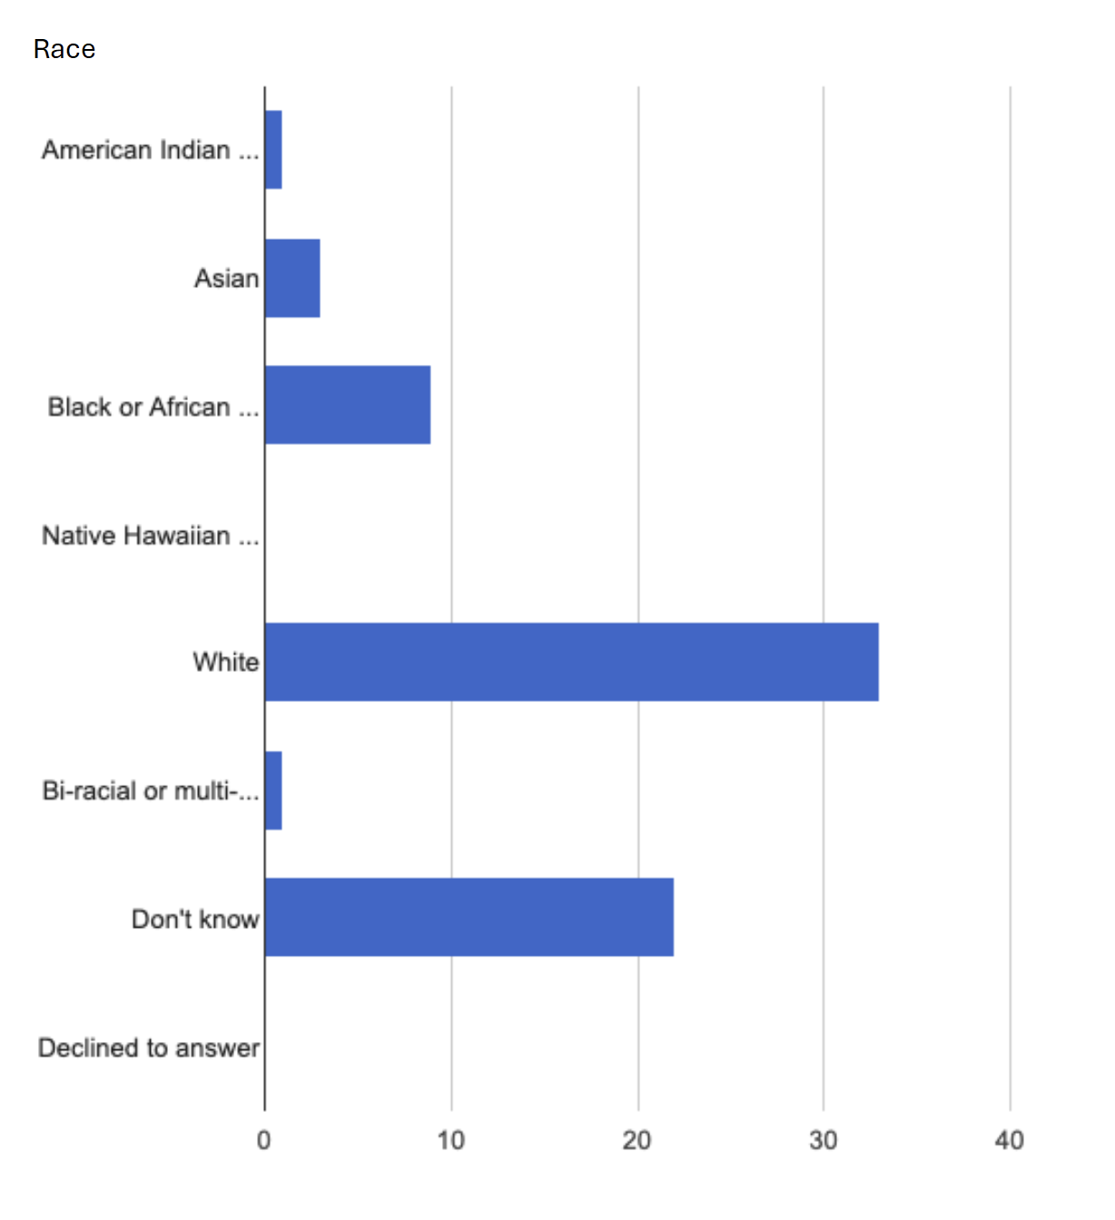

Distribution of Overdose Deaths in Last 12 Months in Washington
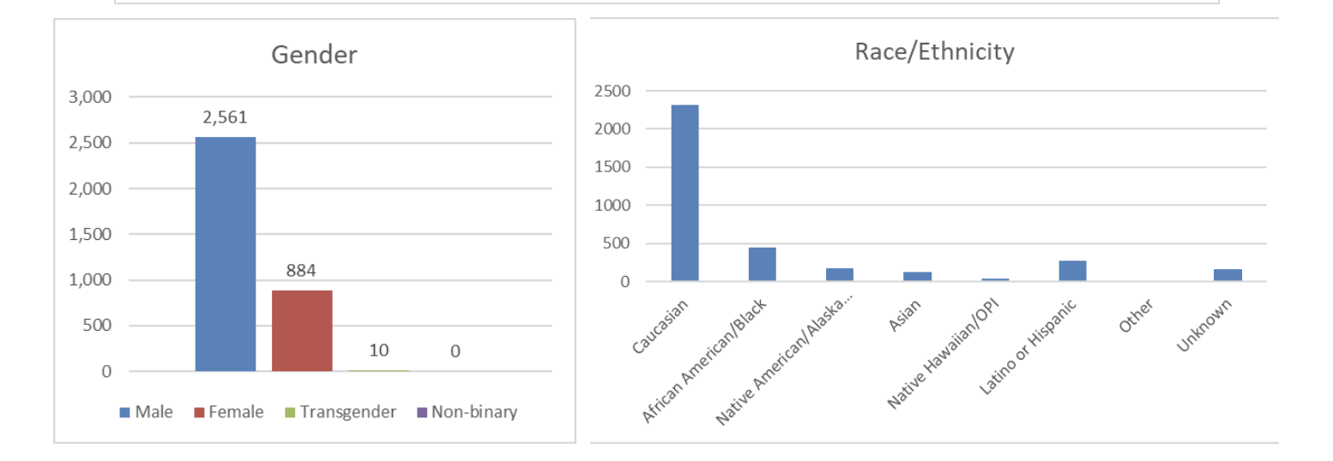

Only 41 (53.2%) patients answered the first follow up call by the LTCCs. On follow-up contact, 51 (64.6%) of them had picked up the buprenorphine, 3 (3.8%) of them had not, and 25 (31.6%) had yet to be contacted. Three patients (8.1%) had used coupons from GoodRx. Thirty three (80%) of the patients had been referred for ongoing treatment. The majority of these patients (65.4%) expressed a preference for in-person follow up care as opposed to follow up care by telehealth.

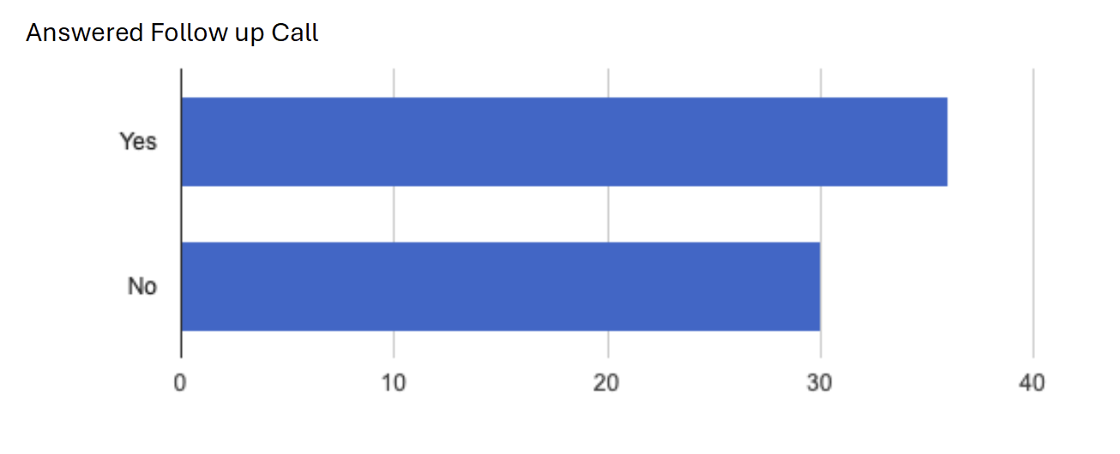

Conclusions:
Telebuprenorphine programs represent an important low-barrier method for people to access timely care for OUD. When a diagnosis of OUD is made, people receive buprenorphine at exceptionally high rates, although some do not pick up the medications. This access is especially important for people at very high risk of overdose death, such as those just leaving incarceration. Reaching the patients for follow up is challenging, and in our experience often involves several phone calls and text messages. However, once reached they are linked to care at very high rates. Further research is needed to understand who fills prescriptions, how and where they link to care, if they stay engaged in care in the medium-to-long term, and the impact of social determinants of health at each stage of care.

