BREAK WAVETM LITHOTRIPSY FOR UROLITHIASIS: RESULTS OF THE FIRST-IN-HUMAN INTERNATIONAL MULTICENTER CLINICAL TRIAL
Ben H. Chew , Jonathan D. Harper , Roger L. Sur , Thomas Chi , Shubha De , Anne R. Buckley , Ryan F. Paterson , Connor M. Forbes , M. Kennedy Hall , Ross Kessler , Seth K. Bechis , Jason R. Woo , Ralph C. Wang , David B. Bayne , Derek Bochinski , Trevor D. Schuler , Tim Wollin , Rahim Samji , and Mathew D. Sorensen

Break Wave Lithotripsy represents a novel non-invasive approach for managing urolithiasis, offering the possibility of treatment with minimal anesthesia which allows stone treatment to extend into non-operative settings such as the ED and outpatient clinic. This abstract presents findings from an initial prospective, multicenter, open-label single-arm clinical trial (NCT03811171) investigating the safety, efficacy, and anesthesia requirements of the SonoMotion (San Mateo, CA) Break Wave device.
A total of forty-four (44) patients with ureteral or renal stones were enrolled from five North American centers (US/Canada) between August 2019 and February 2022. Treatment was administered in various settings including the operating room, office/clinic, or emergency department (ED). Each patient underwent thirty minutes of Break Wave therapy guided by continuous ultrasonography. Different therapy dose levels, up to 8MPa of acoustic pressure, were applied, and safety, effectiveness, and anesthesia requirements were evaluated to determine optimal settings. The primary efficacy endpoint was the stone-free rate or fragments≤4 mm assessed via non-contrast CT at 8-12 weeks by an independent radiologist. Patients were monitored for 90 days with adverse events (AEs) documented.
The distribution of target stones reflected typical locations and sizes, with 59% renal (n=26) and 41% in the distal ureter (DU) (n=18). No serious AEs such as hematomas, cardiac arrhythmia, or sepsis were observed across all dose levels. Notably, 86% of patients required either no medication (50%) or only minor analgesia (36%). Treatment completion was achieved in all cases. Stone fragmentation occurred in 88% of cases, with 70% of patients achieving either complete stone clearance or fragments≤4 mm on CT. The retreatment rate within 90 days was 7% with either SWL or URS. The optimal dose setting was determined and administered to 36 of 44 patients. Among these, 75% had fragments ≤ 4mm, with 58% achieving complete stone clearance. Additionally, 71% of lower pole patients (n=14) had fragments ≤ 4mm, with 29% achieving stone clearance, and 89% of distal ureteral stones (n=18) were completely cleared.
Break Wave Lithotripsy demonstrates both safety and efficacy as a non-invasive stone treatment option, often requiring minimal anesthesia. Its potential suitability for non-operative environments such as the office or ED warrants further investigation in ongoing trials.
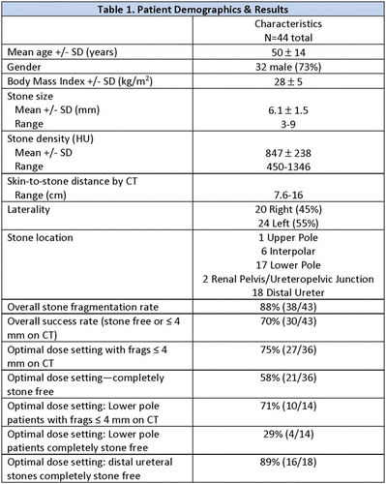

Source of Funding:
Sonomotion, Inc.NIH – NIDDK (R44DK109779)

